Class 11: Process Group Grade of Essay
HW5 : Process plan
Reminder: Writing Center, proofing etc

--Course listings on 9/30 ENG102 + Psy101 LC
TR 9am Williams Psych101 + 10:30 am ENG102
--Rubric
--Sample Grade Process Essay
3 point related activities
-- Banned Book readings
--Video for Human Rights / Maybe other country
link at: http://newclassroom.com/HumanRightsVideo2019.pdf
--Rick & Morty
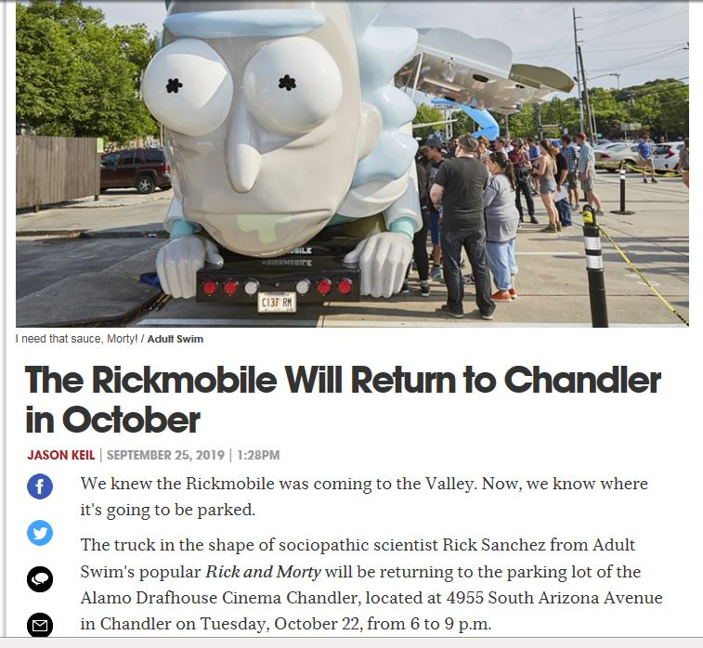

TODAY: GRADE PROCESS ESSAY [Changing front brakes] (+-6) vs PROCESS ESSAY due Tues Oct 1 or due THURS OCT 3

YOUR CLASS
Process Essay RUBRIC CATEGORIES | SCORES:
2. Essay delivers its message/ stays on topic | 10
3. Accurate (could you do action based on details?) | 15
4.Creative/interesting | 5
5. Detailed/specific content/ enough ex. | 10
6. Essay breaks down into relevant paragraphs | 5
8. Grammar & Spelling [0-15] | 20
9. Sentences & Paragraphs. [0-15] | 15
10. Format (MLA style title page) | 5
11. Consistent/Builds | 5
13. Cohesive/Sounds Good | 10
15. Introduction | 0
16. Conclusion | 0

PROCESS ESSAYS DUE THURSDAY & THURSDAY is optional workshop
REMEMBER: Writing Center as well!
HW 7 DUE TONIGHT

QUIZ 6: AFTER THE GROUP ACTIVITY(??) on How To CHANGE IT:
Manage For The Four Types Of Motivation
http://www.fastcompany.com/3050634/hit-the-ground-running/how-to-manage-for-the-four-types-of-motivation

QUESTION: Imagine you are a manager now in charge of a team from a company that YOUR corporation has just taken over. Their managers have been fired and morale is low in this team.

Describe how you would leverage EACH of the 4 methods of inspiring motivation to get your team. Make sure each has an example of how you would do this

