Class 7: Revising & Proofing + Narrative Essay rubric + How to grade sample Narrative with rubric + HW3 due

Give HW5 (yes we are skipping HW 4 for now): Revising suggestions for “Meet: What’s for Dinner”
HW 5 due THURSDAY

NEXT CLASS:
No quiz on Thursday – study for the GBS exam!!!!!
On 9/17 R: GROUP GRADE *REAL* sample narrative essay (“PinWorms”): If at least ¾ of groups come within 6 points of actual grade, NARRATIVE ESSAY is MINIMUM of 3 pages instead of 4!!!!!!!

Narrative Essay due: 9/22 T

NOTE: 1 credit internship class: GBS298 W 1-2:15 Sept 30 – Dec 9
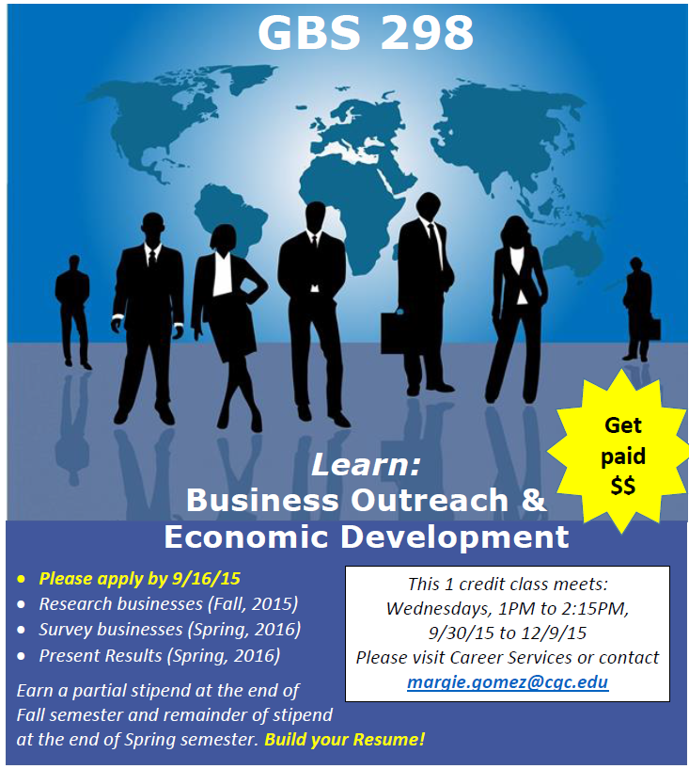
Students will learn valuable skills, gain a rare opportunity to network with business leaders, and be paid. This is the type of internship that students would do free because of the valuable experience, but here they can also be paid.
I have attached a Powerpoint slide to share with your students along with a job description, application, and flyer.
Students need to email their application (and resume) to margie.gomez@cgc.edu. The deadline to apply is 9/16. Please offer to be a reference for your students and encourage them to apply.
Up to 10 minute interviews will be conducted on Monday 9/21 and Wednesday 9/23.
This 1 credit class is on Wednesday from 1PM to 2:15PM from 9/30/15 to 12/9/15.
This class is being team taught along with the Gilbert Chamber of Commerce and the Economic Development Office.
Students will learn what they need to know, be supported, and will work in a team.
The pay rate is $10/hour.
http://newclassroom.com/GBS298APPLICATION.docx
http://newclassroom.com/GBS298DESCRIPTION.docx

- Revising & Proofing

All-Purpose (Creative or expository) Writing Steps

I. Prewriting steps including idea brainstorming

II. Brainstorming on Paper

III. starter draft/ zero draft

IV. first draft

V. Revising [for content] drafts

VI. Proofreading [for errors]

VII. Submission draft

REVISING and PROOFING
1)The Writing Checklist
2)Writing Center: LIB 230 +2 pts E.C. (bankable anywhere incl quiz)

3)http://www.paperrater.com

4)Sentence, Grammar & Word Choice Problems:
*MOST COMMON CATEGORY 4 MISTAKE: sentence fragments, comma issues
http://www.grammarly.com

ENTER INTO GRAMMARLY.com:

Accounting
The primary career I hope to have is to become an accountant. This career need much attention to the supply and demand curve. It also requires much needed attention to paying attention to the company’s revenue and spending. So the job of an account would be to help the company manage its self to be able make the best profit margin it can. I will need to get an associate’s degree, and get a job at a place that would be willing to train a greeny to the field of accounting. An idea that I have is to shadow one of my close friends that has been doing his accounting for the last 40 years, in which he will help me to understand the ends and out of accounting.
The most important jobs skills that I will need are active listening, my persuasion skills, another ability that is very important is being socially perceptive to others, and one of the other ones that I will need as well would be being coordinated as in adapting to different situations very quickly and doing it with precision.
Things that I will really need to focus most on so that I can reach this position will be focusing on my math skills and economics. Math is something very important in accounting because you keeping track of numbers and doing problem solving to make it so you can see the probably out comes to a certain input. The economic side of things is much needed because without this field you understand the important of both macro and micro economics and how with each one you can apply a needed group to allow our company grow in leaps and bounds. Accounting is a competitive job because there are a lot of people that are working towards being an accountant so to really keep your job or to get one you really need to be a go getter, you also need to stand out from the other accountants and go the extra mile.
Some of the greatest risks that I face in this job would be instructing people to make certain choices so that the business can grow and make more money but know the way people work I know that many people don’t take heist to doing things that they don’t understand so they just don’t end up caring and they basically say to hell with that, and by doing this it could affect the company a big deal which in turn makes me look bad and worthless. Another risk that I face before me is being socially perceptive which is understanding the different situations that people are facing sometimes as people we say forget what’s going on at home and just get to work and put forth your best effort. But this thinking isn’t considerate but we think this way many times so actually being considerate to my fellow employees and understand that they won’t always have the best day or we won’t agree with something so I will need to adapt according to their needs.
Some important things that I should really focus on perfecting in this field of work is my mathematic problem solving, understanding the role of the stakeholders in economics and how to satisfy their needs, focusing on being understanding and adaptable, getting familiar with all the accounting programs so that I can be able to do things more efficient and effective, and lastly focusing on the arts of persuasion to be able to more easily help others do what I need them to do. If I can master these five different skills I know without a doubt I will be a very competitive and successful accountant and I know that I can reach the job that I desire, and I know that I can reach it in 5 years at least if not more.

Grammarly and pinpoint are used by Human Resource for cover letters/letter of inquiry
Most set threshold 85-95
Meaning if score less than threshold, instantly throws out resume

II. So how will it be graded: what is a rubric? Let’s give out the points!
Split Out of 70 pts…(grammar and sentences and paragraph = 30 pts)

FINAL VERSION OF AGREED UPON RUBRIC FOR NARRATIVE ESSAY:
Narrative Essay Out of 100 pts (Negotiated) | LAST YEAR’S Narrative Essay
1. Topic Appropriate ____ | 1. Topic Appropriate [0-5]
2. Essay delivers its message/stays on topic ____ | 2. Essay delivers its message/stays on topic [0-10]
4. Creative/uncommon [] ____ | 4. Creative/clever/uncommon [0-5]
5. Detailed/specific content/ enough ex. _____ | 5. Detailed/specific content/ enough ex and not just fluff/stuffing. [0-10]
6. Essay breaks down into relevant para. _____ | 6. Essay breaks down into relevant para. [0-5]
7. Strength of imagery _____ | 7. Strength of argument or Strength of imagery [0-5]
8. Grammar & Spelling _15pts | 8. Grammar & Spelling [0-15]
9. Sentences& Para. 15 pts | 9. Sentences & Para. [0-15]
10. Format __AUTO___ | 10. Format [0-5]
11. Consistent/Builds _____ | 11. Consistent/Builds [0-5]
12. LENGTH (double spaced, Name, date at top)  < min pages = 0/F  Between middle and bottom of page 4= -20  From top to middle of page 4 = -30 | NOT NEGOTIABLE
13. Cohesive/Sounds Good /____ | 13. Cohesive/Sounds Good [0-10]
15. Introduction _____ | 15. Introduction [0-5]
16. Conclusion _____ | 16. Conclusion [0-5]
Last year NARRATIVE: 10 A’s, 7 B’s, 3 C’s, 3 F (all were too short), 2 drops

Things to REMOVE from content drafts:
Adapted from http://www.du.edu/~mtursi/revising_fiction.html
1) preachy language [open attack all bureaucracy by telling reader so, the ‘salvation’ purity effect]
2)remove clichés (dream sequence, ‘was a dark and stormy night’)
3) rewrite boring, non-descript main characters
4) things that would be impossible for a character to know
example:
The moment he laid eyes on the lifeless body of the socialite sprawled across the bathroom floor, Detective Leary knew she had committed suicide by grasping the cap on the tamper-proof bottle, pushing down and twisting while she kept her thumb firmly pressed against the spot the arrow pointed to, until she hit the exact spot where the tab clicks into place, allowing her to remove the cap and swallow the entire contents of the bottle, thus ending her life.
5) bland or repetitive language [avoid just using he said, she said, for dialogue
example:
The sun, setting, meant the end to a sunny day, and the beginning of darkening night until the sun rose again at sunrise. ]
6) inappropriate imagery
example: [‘turned up her nose like unluckily catching a whiff of her own flatulence’] [from Throw Momma Off the Train: ‘Mrs. Hazeltine: [reading her manuscript]: His guts oozed nice, like melted malted icecream.’]
7) Too complex, too much detail, over the top language – especially in the middle of action or conflict. http://bulwer-lytton.com/
example:
Gripping his six-shot Colt Python with 8-inch barrel and Royal Blue finish, and tightening the straps on his Paratec Speed 2000 parachute, Jake leaped from the left aft hatchway of the tumbling, green-and-silver, twin-engined Embraer Lineage 1000, which had seating for nineteen passengers.

8) confusing sentence
[anguished English examples]
”
“Benjamin Franklin died in 1790 and is still dead”

“Iraqi head seeks arms”

“A man eating piranha mistakenly sold as a pet fish”

“Donations fund set up for beating victim’s family” !!Donations fund set up for the family of the beating victim!!

“If Lincoln were alive today, he’d be turning over in his grave” President Gerald Ford

BAD SENTENCE: There would be jail time for the tomato throwers, while the Enron executive with his 12 lawyers and only slightly tomato-stained conscience would be released to celebrate festively with thousand-dollar bottles of champagne, an affront that would be less worse than the fates of thousands: the thousands of now unemployed forced to stand in line for free government cheese for the next years of their lives, frozen ghosts in line forever -- that is -- if the vines of their lives did not yield a more bitter fruit, meaning, of course, the cases of the thousands of despairing apparitions born of hundreds of suicides, suicides that would most likely happen so sadly on broken hearted Christmases without gifts, Turkey, or even, cold, ungarnished, one bean salads.
9) too blatant & obvious symbolism [The dirty cop could be anyone. We are introduced to a cop named Judas McMurphy, etc]
10) pretentious or over precious language (‘perpetual peregrinator’ when you can just say ‘jogger’
example: A single sparkling tear fell from Little Mary's cheek onto the sidewalk, then slid into the storm drain, there to join in its course the mighty waters of the Los Angeles (Lost Angels) River and, eventually, Long Beach Harbor, lost at sea like all the other lost at sea tragedies.
11) Bizarre or too private a reference: “I’m too raging caging to slather with swagger nothing to y’all but props Kanye, you know the bites off the handlebar like a megastar talent terror-phoning it in baggy, right, my slime?”
12) gratuitous violence or sex or language
example [ “She poured acid into his eyeballs, quick drying cement into his nose, and hand sewed his lips shut. Then she decided to begin to torture him]
15) a neat “bow tie” conclusion
[And the janitor came in just in time, leaping through the window. He knocked the gun out of the criminal’s hand, and said, I’m not just a janitor. I’m the father she never knew, and I trained many years in lost martial arts, so now, prepare to fight me to the death and lose!”]

http://withoutbullshit.com/blog/how-to-take-edits/

REVISING: AFTER THE FIRST DRAFT
CHECKLIST/I REVISED FOR CONTENT:  ___1)Improving and Tightening of paragraphs  ___2)Researched details / Fact checked  ___3)storytelling flow: transitions, pace and organization  ___4)Removed repetition and cut for size  ___5)appropriate deep detail  ___6)Edit language/word choice for audience  ___7)Title Play  ___8)At least one unique/memorable image from story  ___9) Always print out and read one of the drafts on paper, not on computer  ___10)Not generic/ could not be written by anyone off the street without ‘my’ experiences | CHECKLIST/ I REMOVED from drafts:  Adapted from http://www.du.edu/~mtursi/revising_fiction.html  ___1) removed preachy language  ___2)removed clichés (dream sequence, ‘was a dark & stormy night)  ___3) rewrote boring, non-descript main characters  ___4)removed things would be impossible for character to know  ___5) removed bland or repetitive language  ___6) removed inappropriate imagery  ___7) removed too complex, too much detail, over the top language – especially in the middle of action or conflict.  ___8) removed confusing sentences  ___9) removed too blatant & obvious symbolism  ___10) removed pretentious or over precious language  ___11) removed Bizarre or too private a reference  ___12) removed gratuitous violence or sex or language  ___13) removed a neat “bow tie” conclusion or ending

SAMPLE TRANSITION WORDS
(IMPORTANT: don’t use transitions before/after each paragraph, only when NEEDED/ ONLY SOME WORK)
1. Because of:  Accordingly  Consequently  As a result  Simply because  Since  therefore | 2. Conditionally  Although  At any rate  Even though  If  In case of  Provided that | 3. Additionally/more examples  Additionally besides too  Again furthermore  Along with next  Also likewise  And also not only  And don’t forget  As well as but also | 4. Resulting in  as a result  accordingly  consequently  then thus  therefore  not surprisingly
5. Emphasis  Above all  Absolutely  Even more importantly  Certainly Especially  Chiefly In fact  Most importantly | 6. Listing an example for a point  For example  For instance  Such as  Illustrates | 7. Opposition contrast  But on the contrary  Contrary to on the other hand  Conversely otherwise probably  However unlike nearly beyond  In contrast yet Almost Somewhat  Is nothing like still Perhaps | 8. Location  wherever  where Here  Above under  Beyond Over there  Everywhere Nearby  Near
9. Sequence  First initially  Secondly then  Thirdly next  Finally lastly  once | 10. Similarly  Just like likewise  Compared to  In the same way  Similarly  Too | 11. Time  After afterward soon then  Always during thereafter  Formerly in the meantime while seldomly  Later meanwhile when now  Never next sometimes since

For next class: GROUP Grading sample narrative, HW 5: revising and giving feedback suggestions for “MEET: What’s for Dinner”
(“PinWorms”): REMEMBER: If at least ¾ of groups come within 6 points of actual grade, NARRATIVE ESSAY is MINIMUM of 3 pages instead of 4!!!!!!!

GROUP # ___________
USE THIS SHEET FOR SCORING version NARRATIVE ESSAY
Members Present: (print names)

_____________________________ _________________________________

_____________________________ _________________________________

_____________________________ _________________________________

Instructions:
1) Either go thru each category as a team, or divide the categories below among the members (for example, team member Ann does categories 1, 2, 6 and 9; team member Bill does 3,5,11,13; etc)

2) Read the sample paper

3) TO DO :
PART I: BELOW, GIVE A POINT VALUE FOR EACH CATEGORY. Add up for FINAL GRADE.

PART II:
4) On a separate page(s), For each category that you did not score as perfect, list at least one specific thing for the category that you could find wrong/could be fixed using the rubric suggestions for that category. When necessary, specify the page# and paragraph #. For example, for category #15: INTRODUCTIONS, if it simply had one sentence with the thesis as a question, you could write:
a) Use a creative example to hook reader
b) State thesis argumentatively
c) Use two paragraphs for the introduction, one to hook the reader and one to set up and state thesis etc

SCORING:.
Category 1 (0-10):_______  Topic Appropriate | Category 6 (0-5):_______  Breaks down into relevant paragraphs
Category 2 (0-10):_______  Essay delivers message/ stays on topic | Category 7 (0-10):_______  Strength of imagery
 | Category 8 (0-15):_______  Grammar & Spelling | Category 13 (Cohesive/sounds good)  (0-5): _______
Category 4 (0-10):_______  Creative/Interesting | Category 9 (0-15):_______  Sentences& Paragraphs | Category 15 (0-3): ___________  Introduction
Category 5 (0-10):_______  Detailed/specific content | Category 10 (0-5):_______  Format | Category 16 (0-2): ___________  Conclusions
FINAL GRADE ___________

